Objective Questions

1. Does any table have missing values or duplicates? If yes how would you handle it ?

1. Find the top-selling tracks and top artist in the USA and identify their most famous genres.

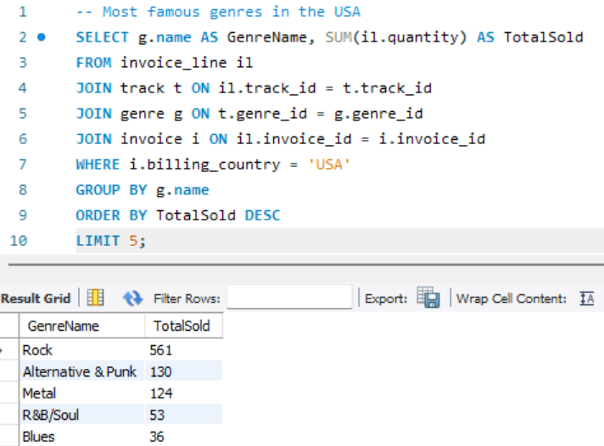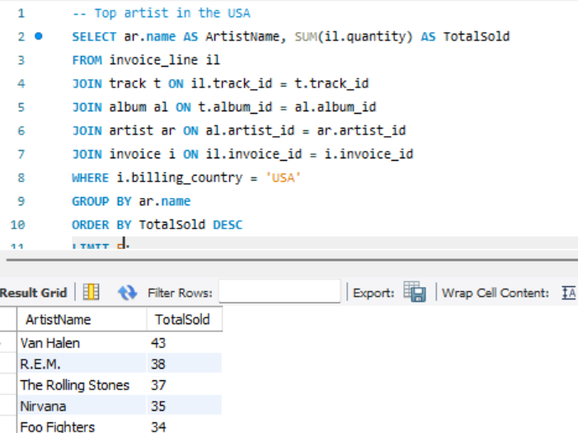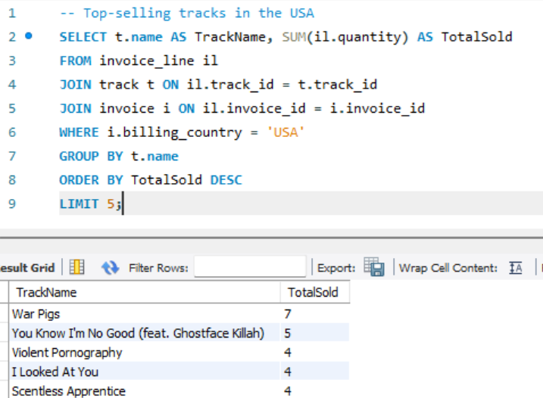

1. What is the customer demographic breakdown (age, gender, location) of Chinook's customer base?

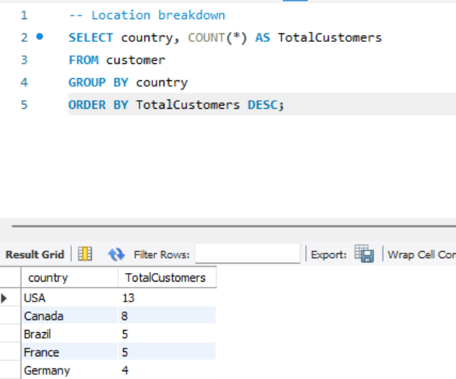

1. Calculate the total revenue and number of invoices for each country, state, and city:

1. Find the top 5 customers by total revenue in each country

|  |  |  |  |
| --- | --- | --- | --- |
|  |  | **Values** |  |
| **Country** | **Customer_id** | **Sum of Total_Revenue** | **Count of Customer_id** |
| **Argentina** | 56 | 39.6 | 1 |
| **Australia** | 55 | 81.18 | 1 |
| **Austria** | 7 | 69.3 | 1 |
| **Belgium** | 8 | 60.39 | 1 |
| **Brazil** | 1 | 108.9 | 1 |
|  | 13 | 106.92 | 1 |
|  | 12 | 82.17 | 1 |
|  | 11 | 69.3 | 1 |
|  | 10 | 60.39 | 1 |
| **Canada** | 3 | 99.99 | 1 |
|  | 30 | 91.08 | 1 |
|  | 33 | 75.24 | 1 |
|  | 32 | 70.29 | 1 |
|  | 15 | 66.33 | 1 |
| **Chile** | 57 | 97.02 | 1 |
| **Czech Republic** | 5 | 144.54 | 1 |
|  | 6 | 128.7 | 1 |
| **Denmark** | 9 | 37.62 | 1 |
| **Finland** | 44 | 79.2 | 1 |
| **France** | 42 | 99.99 | 1 |
|  | 39 | 79.2 | 1 |
|  | 43 | 73.26 | 1 |
|  | 40 | 72.27 | 1 |
|  | 41 | 64.35 | 1 |
| **Germany** | 37 | 94.05 | 1 |
|  | 36 | 85.14 | 1 |
|  | 2 | 82.17 | 1 |
|  | 38 | 73.26 | 1 |
| **Hungary** | 45 | 78.21 | 1 |
| **India** | 58 | 111.87 | 1 |
|  | 59 | 71.28 | 1 |
| **Ireland** | 46 | 114.84 | 1 |
| **Italy** | 47 | 50.49 | 1 |
| **Netherlands** | 48 | 65.34 | 1 |
| **Norway** | 4 | 72.27 | 1 |
| **Poland** | 49 | 76.23 | 1 |
| **Portugal** | 34 | 102.96 | 1 |
|  | 35 | 82.17 | 1 |
| **Spain** | 50 | 98.01 | 1 |
| **Sweden** | 51 | 75.24 | 1 |
| **United Kingdom** | 53 | 98.01 | 1 |
|  | 54 | 79.2 | 1 |
|  | 52 | 68.31 | 1 |
| **USA** | 17 | 98.01 | 1 |
|  | 20 | 95.04 | 1 |
|  | 22 | 92.07 | 1 |
|  | 21 | 91.08 | 1 |
|  | 26 | 86.13 | 1 |
| **Grand Total** |  | **3998.61** | **48** |

1. Identify the top-selling track for each customer

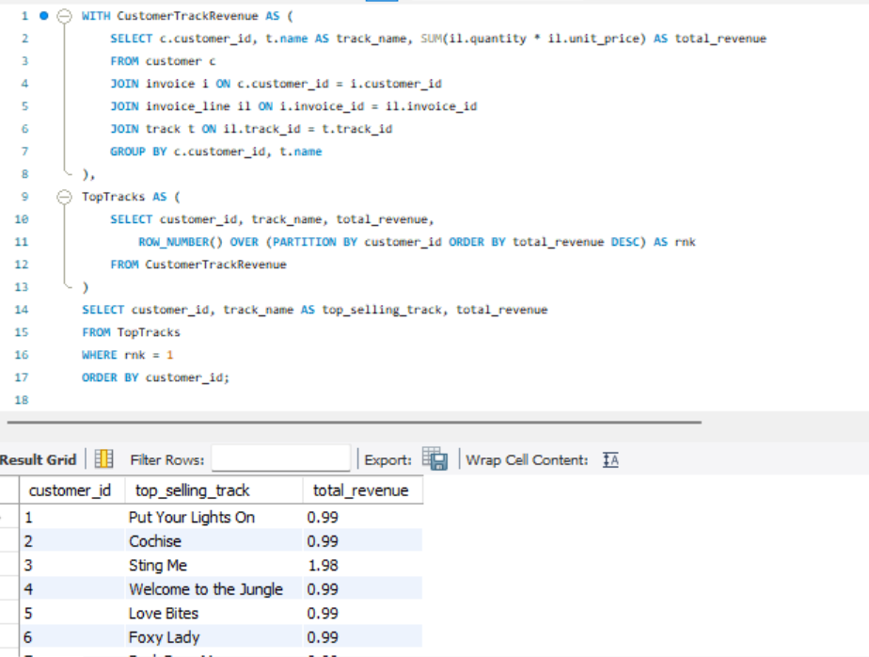

1. Are there any patterns or trends in customer purchasing behavior (e.g., frequency of purchases, preferred payment methods, average order value)?

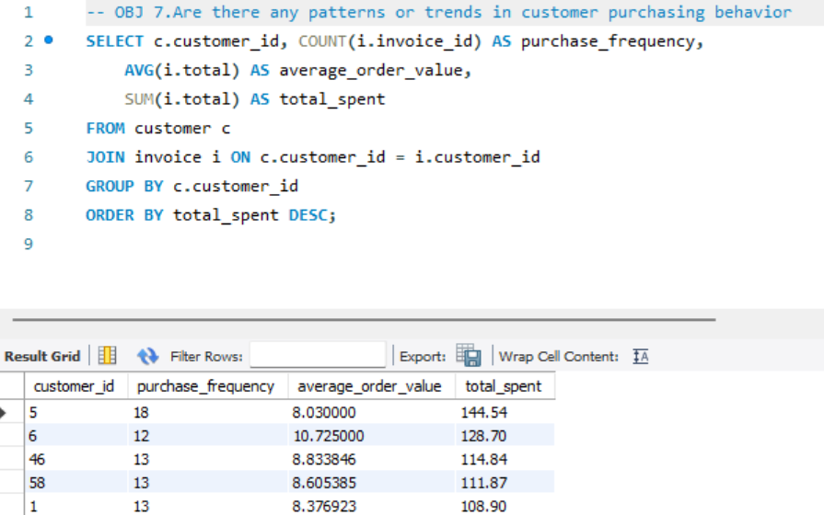

1. What is the customer churn rate?

1. Calculate the percentage of total sales contributed by each genre in the USA and identify the best-selling genres and artists.

1. Find customers who have purchased tracks from at least 3 different genres

1. Rank genres based on their sales performance in the USA

1. Identify customers who have not made a purchase in the last 3 months

**Subjective Questions**

1. Recommend the three albums from the new record label that should be prioritised for advertising and promotion in the USA based on genre sales analysis.

1. Determine the top-selling genres in countries other than the USA and identify any commonalities or differences.

1. Customer Purchasing Behaviour Analysis: How do the purchasing habits (frequency, basket size, spending amount) of long-term customers differ from those of new customers? What insights can these patterns provide about customer loyalty and retention strategies?

**Approach:**

* **Customer Classification:** Define "long-term" customers as those with a tenure greater than 12 months and "new" customers as those with a tenure of 12 months or less.
* **Metric Analysis:** Examine differences between the two groups in terms of purchase frequency, average basket size (spending per transaction), and total spending.
* **Data Grouping and Calculation:** Use tenure data to categorize customers into the defined groups and compute the relevant metrics for each group to identify patterns or trends.

**Insights:**

* Long-term customers tend to shop less frequently but spend more overall, showcasing their loyalty and trust in the brand.
* New customers often make smaller, more frequent purchases as they familiarize themselves with the product range.

**Recommendations:**

* Develop retention strategies for long-term customers, such as loyalty programs or exclusive offers.
* Design onboarding campaigns to encourage new customers to increase their purchase size, such as providing discounts for larger orders.

1. Product Affinity Analysis: Which music genres, artists, or albums are frequently purchased together by customers? How can this information guide product recommendations and cross-selling initiatives?

* Explanation:
  + **Identify Genre Pairs**: The GenrePairs CTE finds genre pairs that appear together in the same invoice, ensuring they are different tracks.
  + **Count Co-occurrences**: The main query counts how often each pair appears together in invoices.
  + **Order and Limit**: Results are sorted by frequency, showing the top 10 pairs.
  + **Adaptability**: This approach can be applied to artists or albums by replacing genre data with artist or album information.
* **Insights**:
  + Recommend frequently co-purchased genres together.
  + Identify complementary artists or albums for bundles.
  + Improve recommendations based on past purchase patterns.

1. Regional Market Analysis: Do customer purchasing behaviors and churn rates vary across different geographic regions or store locations? How might these correlate with local demographic or economic factors?

**Approach**:

* Group customers by country and calculate their total spending.
* Rank customers within each country based on their total revenue.

**Insights:**

* High-value customers significantly drive revenue, often aligning with the "80/20 rule" (Pareto principle).
* These customers tend to be highly engaged, presenting strong opportunities for upselling and cross-selling.

**Recommendations:**

* Prioritize marketing and relationship management strategies for these top-tier customers.
* Implement personalized promotions to strengthen loyalty and boost their lifetime value.

1. Customer Risk Profiling: Based on customer profiles (age, gender, location, purchase history), which customer segments are more likely to churn or pose a higher risk of reduced spending? What factors contribute to this risk?

### Factors Contributing to Customer Risk

1. **Purchase Behavior**:
   * Infrequent purchases or long gaps between purchases.
   * Low or declining spending over time.
2. **Demographics**:
   * Regional differences in spending patterns.
   * Age or gender preferences (if available).
3. **Product Fit**:
   * Limited variety in purchases.
   * Mismatch between customer preferences and offerings.
4. **External Factors**:
   * Competition offering better options.
   * Economic downturns affecting spending.
5. **Engagement**:
   * Lack of recent activity.
   * Impersonal marketing or communication.
6. Customer Lifetime Value Modeling: How can you leverage customer data (tenure, purchase history, engagement) to predict the lifetime value of different customer segments? This could inform targeted marketing and loyalty program strategies. Can you observe any common characteristics or purchase patterns among customers who have stopped purchasing?

**Approach:**

* Analyze customer data to determine purchase frequency, average order value, and preferred payment methods.
* Identify trends, recurring patterns, and any unusual behaviors in the data.

**Insights:**

* Frequent buyers are likely a key segment of highly engaged customers.
* Higher average order values may suggest a preference for bundles or premium products among certain customers.

**Recommendations:**

* Offer loyalty points or discounts to reward frequent buyers and encourage repeat purchases.
* Provide incentives, such as discounts on bulk purchases, to motivate customers with lower average order values to spend more.

1. If data on promotional campaigns (discounts, events, email marketing) is available, how could you measure their impact on customer acquisition, retention, and overall sales?

To measure the impact of promotional campaigns, analyze three key areas:

* + **Customer Acquisition**:
    - Count new customers during the campaign period.
    - Example: Customers who made their first purchase during the campaign.
  + **Customer Retention**:
    - Track how many campaign customers made repeat purchases afterward.
  + **Overall Sales**:
    - Measure total sales, number of orders, and average order value during the campaign.

**How:**

* + Use SQL queries to compare campaign metrics (e.g., new customers, sales) with:
    - Data from before the campaign.
    - The same period in previous months or years.

This helps you see if the campaign attracted new customers, retained existing ones, or boosted sales.

1. How would you approach this problem, if the objective and subjective questions weren't given?

* Conduct exploratory analysis to examine data structure, quality, and relationships.
* Define business objectives such as revenue growth or customer retention.
* Formulate hypotheses and key questions based on objectives.
* Prioritize queries with the highest business impact.

1. How can you alter the "Albums" table to add a new column named "ReleaseYear" of type INTEGER to store the release year of each album?

1. Chinook is interested in understanding the purchasing behavior of customers based on their geographical location. They want to know the average total amount spent by customers from each country, along with the number of customers and the average number of tracks purchased per customer. Write an SQL query to provide this information.

SELECT c.country, COUNT(DISTINCT c.customer_id) AS CustomerCount, AVG(i.total) AS AvgSpending, AVG(il.quantity) AS AvgTracksPerCustomer

FROM invoice i

JOIN customer c ON i.customer_id = c.customer_id

JOIN invoice_line il ON i.invoice_id = il.invoice_id

GROUP BY c.country

ORDER BY AvgSpending DESC;